## **Assignment-1: Warm-up with Python**

**1. Write a command to get the Python version you are using.**

**Ans.** python –version

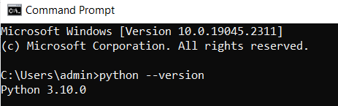

**2. Write a python script to print Hello Python on the screen directly in the command**

**Line.**

**Ans.** First Enter python, and then enter whatever you want to print. In our case it print(“Hello World”)

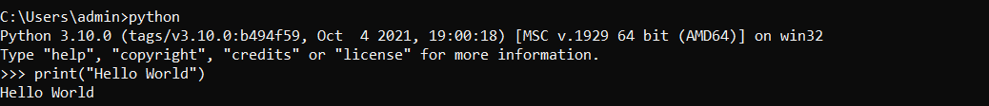

**3. Write a python script and store it in a file and execute the file from the command line.**

**Ans.**

First we need to write some program let’s say sum of two numbers.

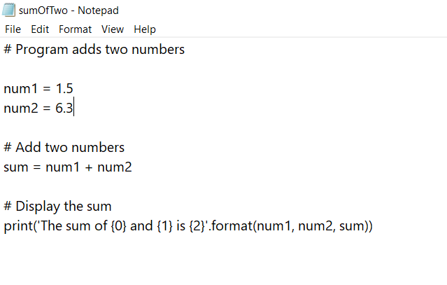

Save this file as sumOfTwo.py name. And run this file on command line.

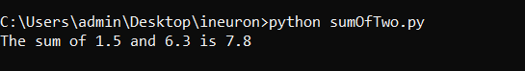

**4. Write a python script to print Hello Python on the screen using visual studio code.**

**Ans,**

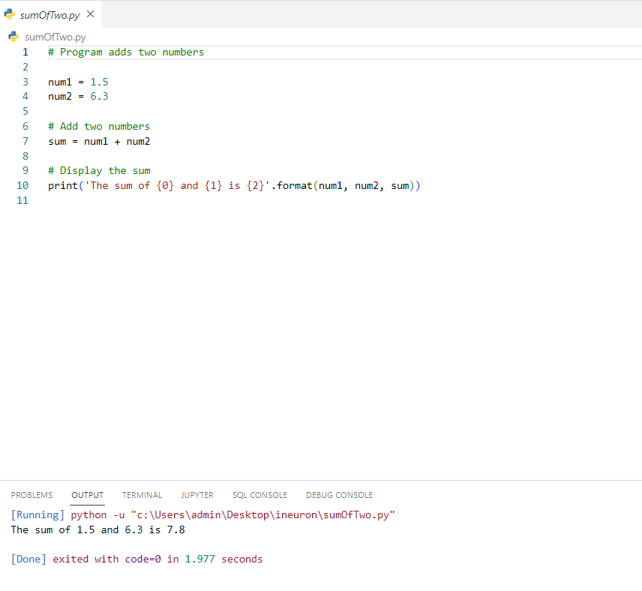

**5. Write a python script to print Hello on the first line and Python on the second line**

**Ans,**

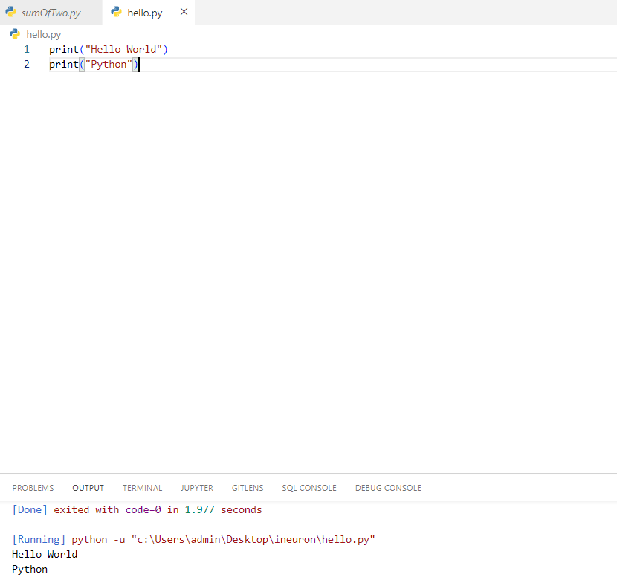

**6. Write a python script to print “MySirG” on the screen**

**Ans.**

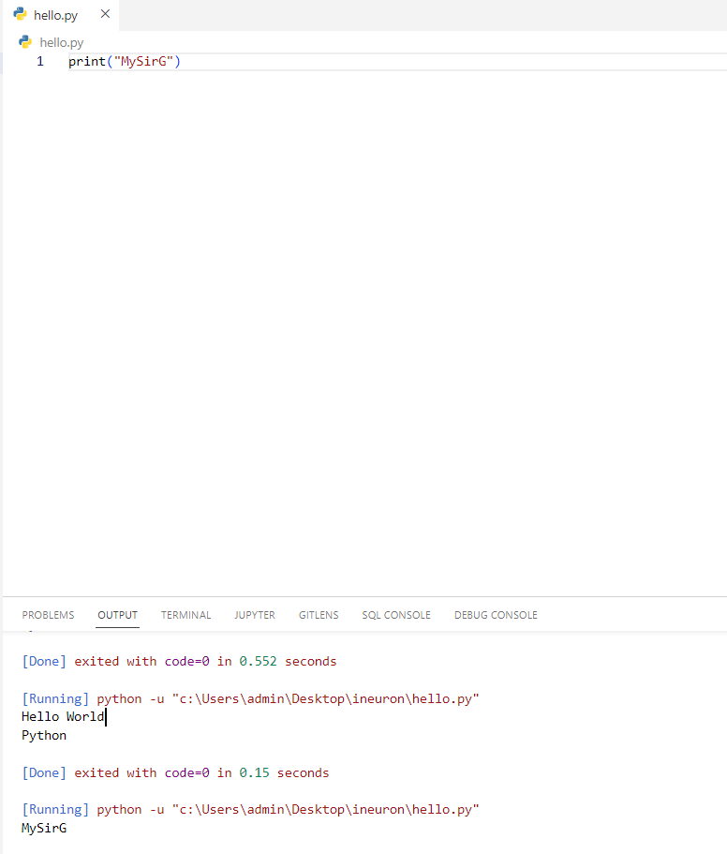

**7. Write a python script to print “Teacher’s Day” on the screen.**

**Ans.**

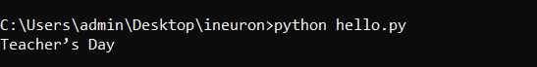

**8. Write a python script to print the value of a variable. Variable contains your name as**

**Data.**

**Ans.**

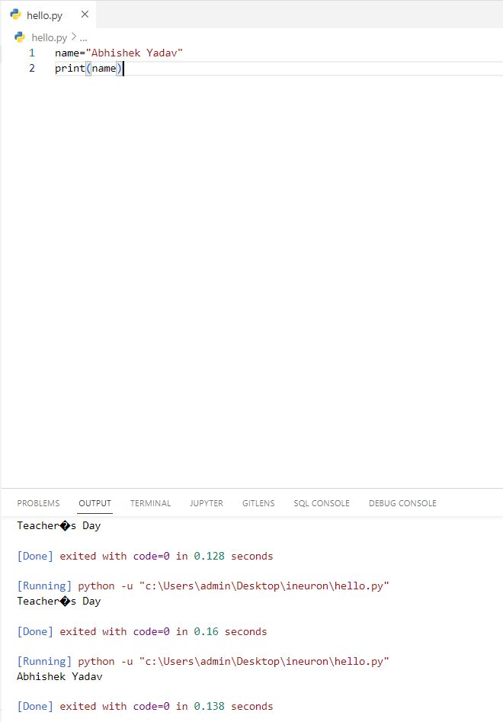

**9. Write a python script to create variables to store your name, age, qualification, years**

**of experience and print it.**

**Ans.**

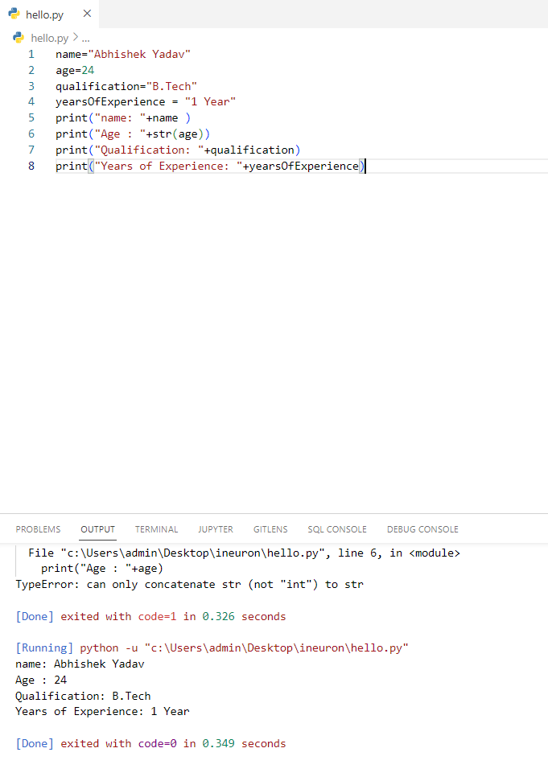

**10. Write a python script to print values of three variables, each in a new line. Variable**

**contains integer values**

**Ans.**

